After clicking into the Draws and Results section of the ESFA website you will see the ‘Online Membership Database Login’ and you will need to click on this menu item.

This will be the next screen you see and you need to click on the Login to your membership database

This is the next screen, where you will either need to Sign In or Register for a SP Passport (Sporting Pulse). You will only need to register once, however each person wanting to access will either need to know the email address and password to access the system or they will need to register themselves.
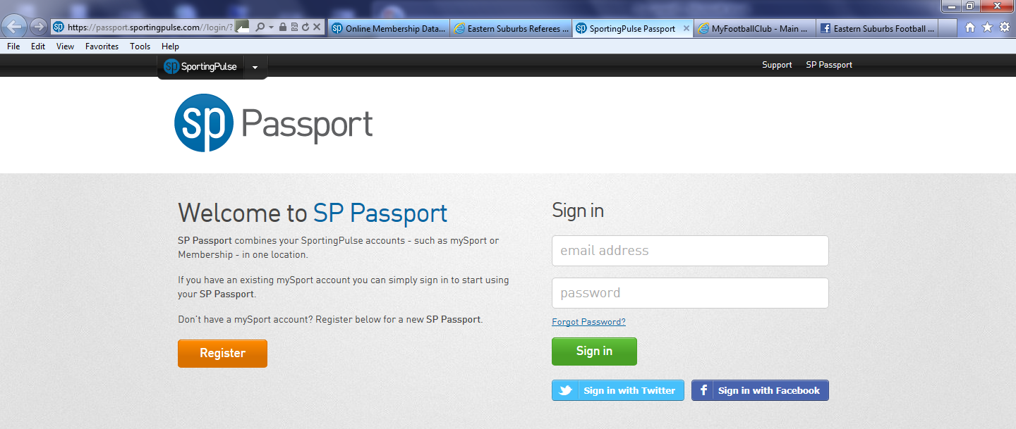

This is the registration screen, and once you have completed this an notification will be sent to your email account to verify and activate the ‘passport’.
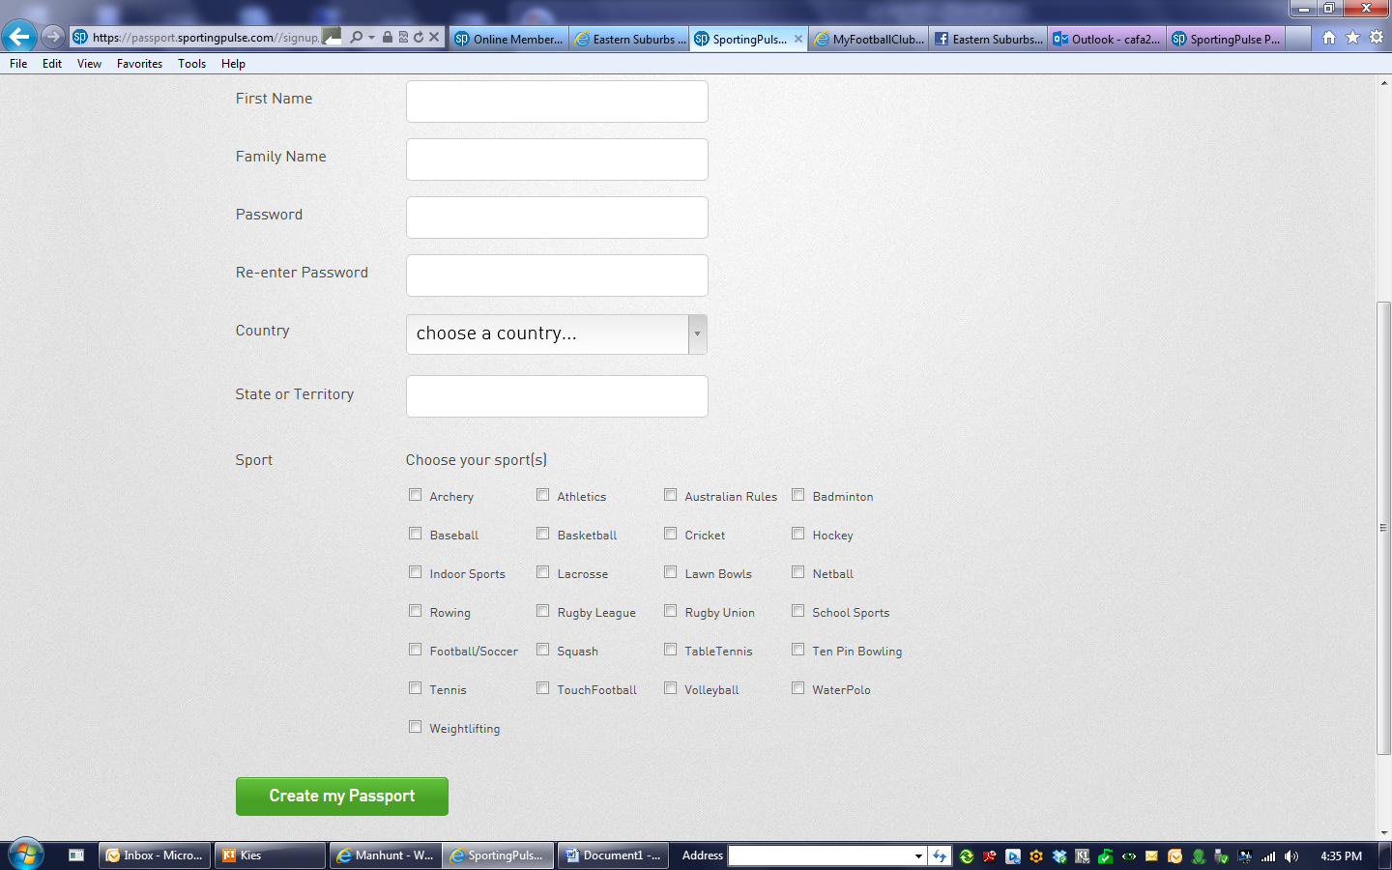

Once you have completed registration and verified your passport, send us the email address attached to the passport and the club or team for which that passport should be granted access.
Once we have given you access, you can sign in using the email address and password you have created.
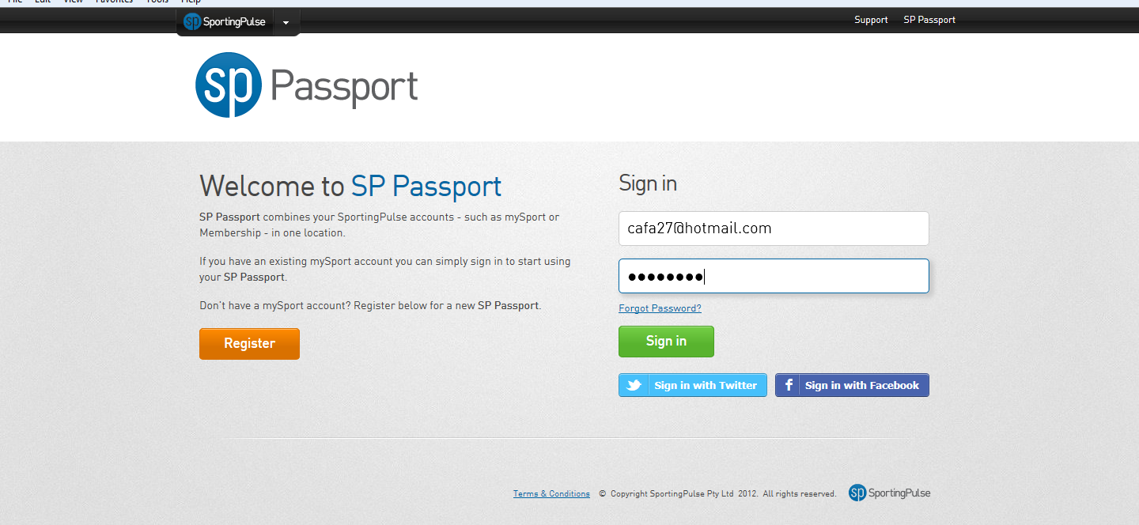

Once you have signed in with the email address and password you will need the USERNAME and PASSWORD which was sent in the email. The USERNAME and PASSWORD is for ALL of the club, if you would like individual USERNAME and PASSWORDS for teams, please advise so we can update this.
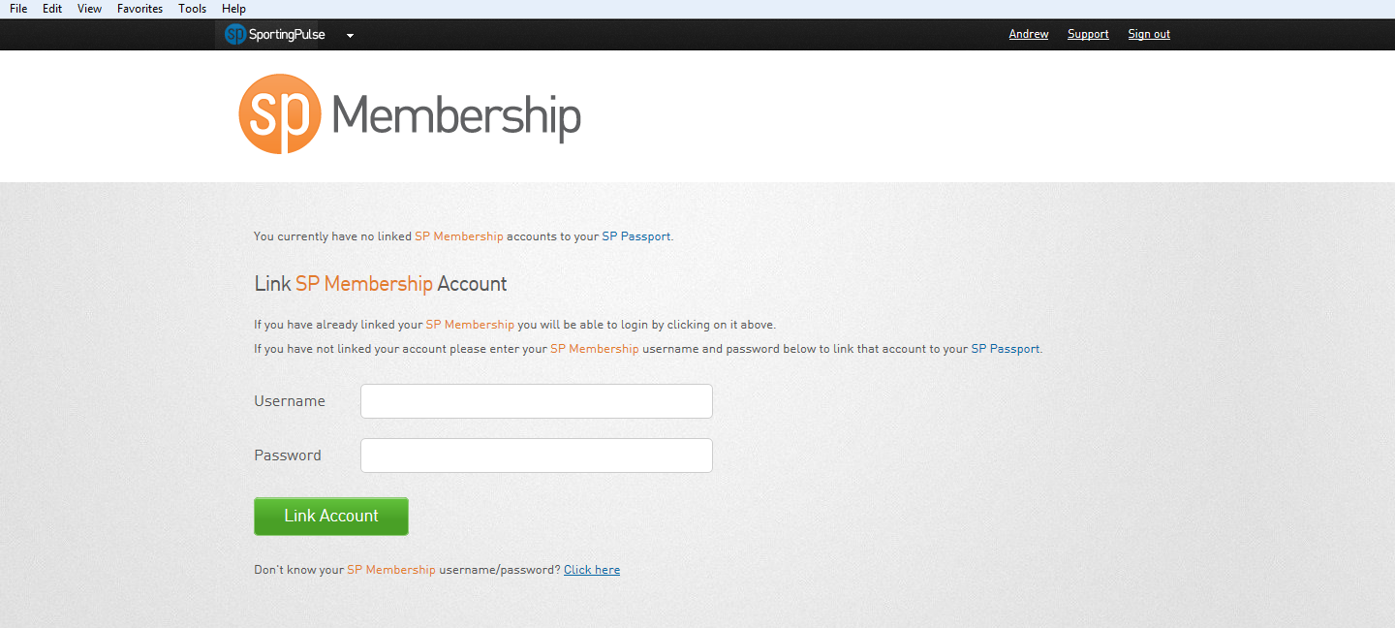

Once you have entered the details above your will see the next screen, with your clubs details and/or logo, click on the club name or logo
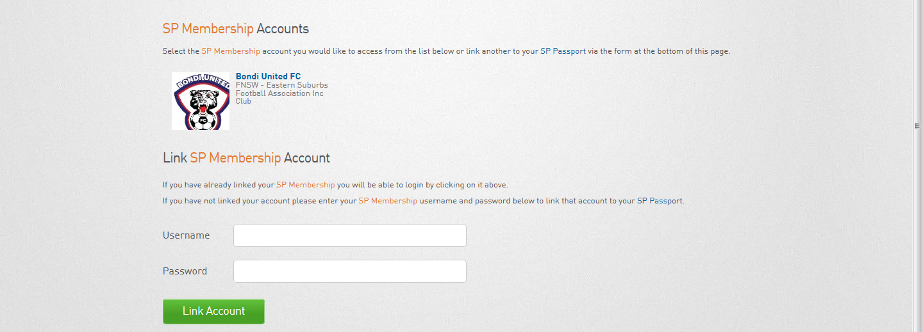

Next screen you will see is below. Click on ‘TEAMS’.
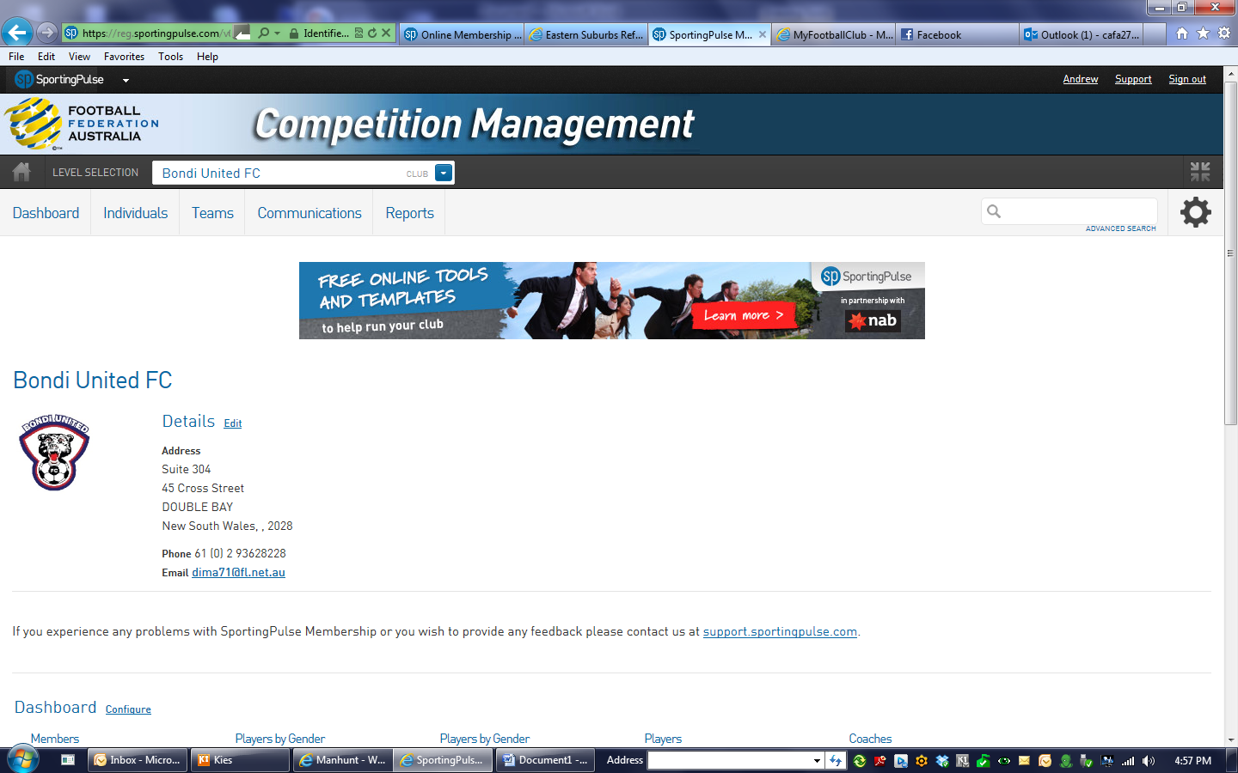
Click on the magnify glass on the left side of any team
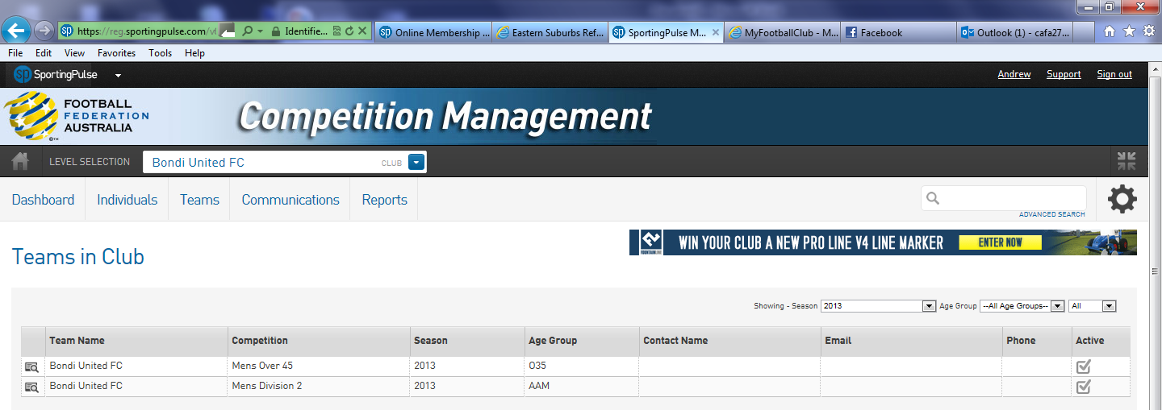

From this screen click on ‘Match Results’, which will take you to the area to enter the scores.

Check to make your the matches are in the correct date range. You can also filter the matches to certain fields, such as your home field first or particular age groups or divisions. Then click on ENTER QUICK RESULTS.
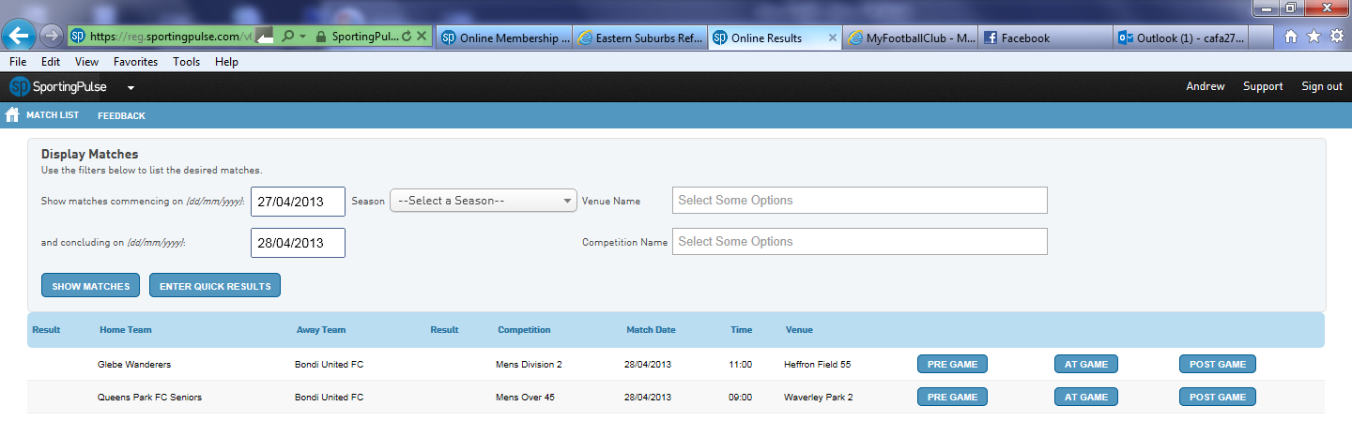
Nothing has changed since last season here, please remember we only require the Full Time score which is FTS in the table. Once you have finished click the SAVE QUICK RESULTS at the bottom of the screen. You can then SIGN OUT, which is at the top right.
